Home Display

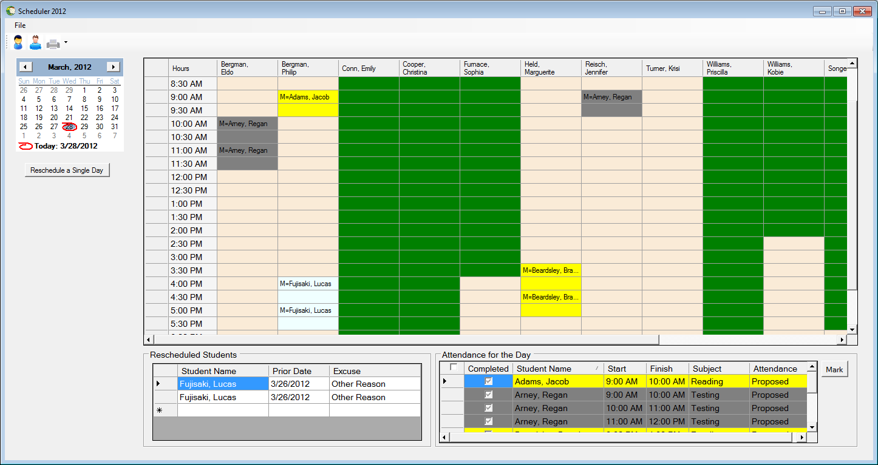

d e

a b c g f

1. Home Menu
2. The Home Menu will allow the user to navigate to other areas of the scheduler software.

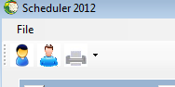

**Single Day scheduling:**  allows the user to reschedule a student to any available clinician within any given selected day. See Reschedule Daily display for details.

**Multiple Day scheduling:** allows the user to schedule and reschedule student on multiple/single days and stores additional information about the user.

**Clinician Manager:** Gives the user the ability to add or edit clinicians’ personal information, and active status as well as schedule a clinician to be off for single or multiple days.

**Student Manager:** Gives the user the ability to add or edit students’ personal information, and active status as well as their guardians’ information.

**Print:** Allows the user to print an *Office Schedule* or any *Student Calendar*.

**Exit:** Closes the Scheduler Software

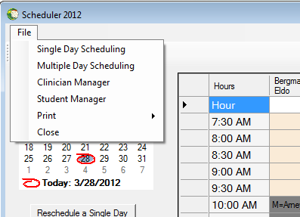

1.  **Student Manager:** Gives the user the ability to add or edit students’ personal information, and active status as well as their guardians’ information.
2.  **Clinician Manager:** Gives the user the ability to add or edit clinicians’ personal information, and active status as well as schedule a clinician to be off for single or multiple days.
3.  **Print:** Allows the user to print an *Office Schedule* or any *Student Calendar*.
4. Reschedule Schedule a Student to different time and clinician

**Single Day scheduling:**  allows the user to reschedule a student to any available clinician within any given selected day.

1. Reschedule a single day

Clicking on this button opens a screen which allows the student to be rescheduled to a different time slot or clinician within the same date. See Reschedule Daily display for details.

1. Calendar control

When the user selects a date on the calendar the entire schedule for that date will be displayed.

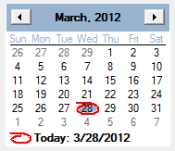

Select arrow to go forward by one month or backward by one month

Reminder of the current date

This is a reminder of the current date. When the user clicks on the date it will return back to the current month and date

1. Rescheduled Students

A listing of all the students who have been reschedules from a prior date.

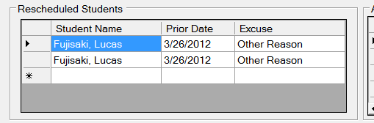

1. Attendance for the day

A listing of all students scheduled for the selected day in alphabetical order, it is an alternative display for locating a student.

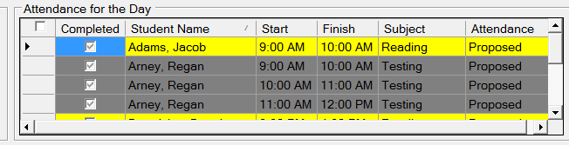

Color coded according to status.

1. A checkmark indicates a student is present.

2) Unchecked indicates a no-show

3) Greyed checked mark will set the student to their original default state.

1. Mark Button

Marks a student as being present or absent with the mark attendance button.

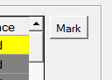

1. Main display

A display grid of the entire schedule of a day which is selected from the *calendar control.*

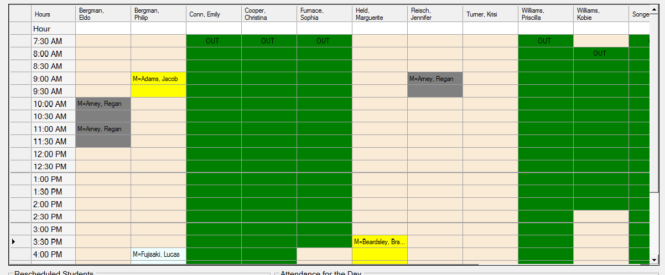

Each row represents a half hour time slot and each column heading list the active clinicians.

Yellow: is an originally proposed time

Green: Clinician is scheduled to be out

Grey: Meeting

Blue: Completed

Red: Absent

Light Blue: Was rescheduled from a previous date

White: Hours one or two of a particular student

Orange: Student is scheduled to be located offsite.

f